**Data Communication and Computer Networks**

**LAB # 06**

**Wireshark Lab: DHCP**



**Spring 2023**

Submitted by: **Safi Ullah Khan**

Registration No. : **20PWCSE1943**

Class Section: B

Submitted to:

**Engr. Yasir Saleem Afridi**

**Department of Computer Systems Engineering**

**CSE 303L: Data Communication and Computer Networks**

|  |  |  |  |  |
| --- | --- | --- | --- | --- |
| **Demonstration of Concepts** | **Poor (Does not meet expectation (1))**  The student failed to demonstrate a clear understanding of the assignment concepts | **Fair (Meet Expectation (2-3))**  The student demonstrated a clear understanding of some of the assignment concepts | **Good (Exceeds Expectation (4-5)**  The student demonstrated a clear understanding of the assignment concepts | **Score**  **30%** |
| **Accuracy** | The student mis-configured enough network settings that the lab computer couldn't function properly on the network | The student configured enough network settings that the lab computer partially functioned on the network | The student configured the network settings that the lab computer fully functioned on the network | **30%** |
| **Following Directions** | The student clearly failed to follow the verbal and written instructions to successfully complete the lab | The student failed to follow the some of the verbal and written instructions to successfully complete all requirements of the lab | The student followed the verbal and written instructions to successfully complete requirements of the lab | **20%** |
| **Time Utilization** | The student failed to complete even part of the lab in the allotted amount of time | The student failed to complete the entire lab in the allotted amount of time | The student completed the lab in its entirety in the allotted amount of time | **20%** |

**Credit Hours: 1**

What to Hand In:

You should hand in a screen shot of the Command Prompt window similar to Figure 1 above. Whenever possible, when answering a question below, you should hand in a printout of the packet(s) within the trace that you used to answer the question asked.

Annotate the printout3 to explain your answer. To print a packet, use File->Print, choose

Selected packet only, choose Packet summary line, and select the minimum amount of packet detail that you need to answer the question.

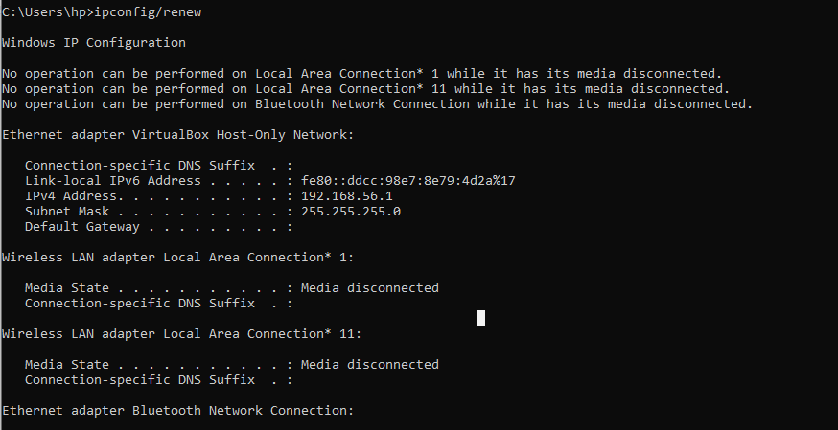 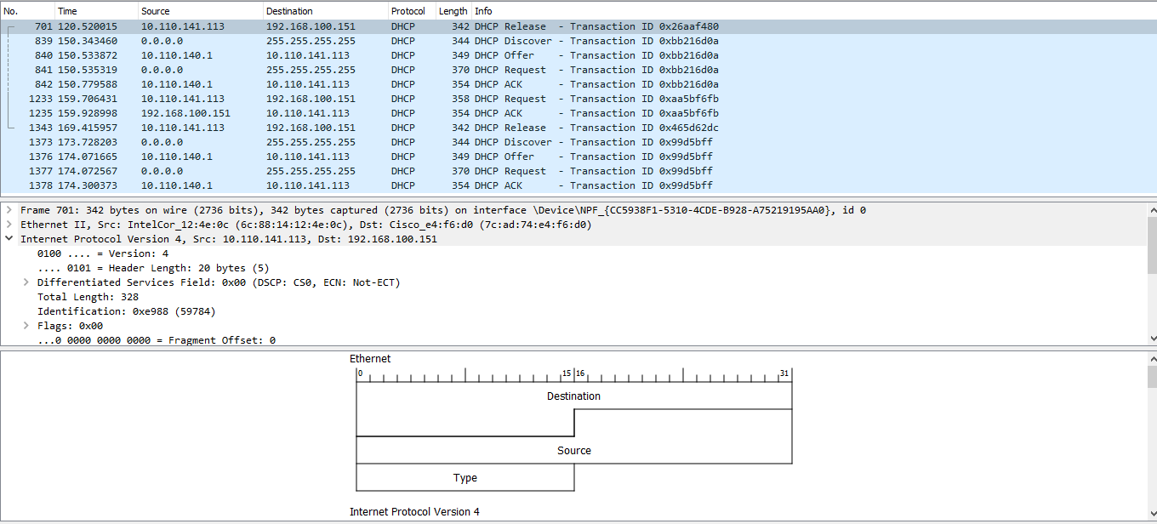

Answer the following questions:

**QUESTION:1**

Are DHCP messages sent over UDP or TCP?

DHCP messages sent over UDP.

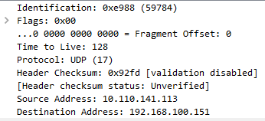

**QUESTION:2**

Draw a timing datagram illustrating the sequence of the first four-packet

Discover/Offer/Request/ACK DHCP exchange between the client and server. For

each packet, indicated the source and destination port numbers. Are the port

numbers the same as in the example given in this lab assignment?

Yes the port numbers in the example are same.

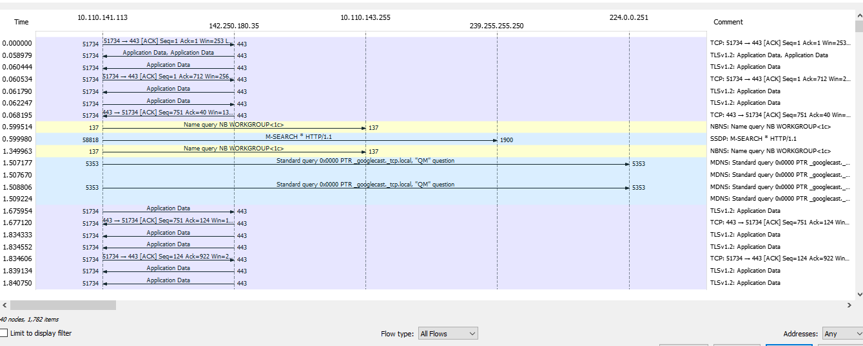

**QUESTION:3**

What is the link-layer (e.g., Ethernet) address of your host?

**ANSWER:**



**QUESTION:4**

What values in the DHCP discover message differentiate this message from the DHCP request message?

**ANSWER:**

**Discover message:**

The value in the DHCP discover message is 1

**Request message:**

The value in the DHCP request message is 3

**QUESTION:5**

What is the value of the Transaction-ID in each of the first four (Discover/Offer/Request/ACK) DHCP messages? What are the values of the Transaction-ID in the second set (Request/ACK) set of DHCP messages? What is the purpose of the Transaction-ID field?

**ANSWER:**

**Purpose:**

The purpose of the transaction ID is it help the server and client ensure they are trying to achieve the same thing.

**1ST FOUR:**



**2nd Set :**



**QUESTION:6**

A host uses DHCP to obtain an IP address, among other things. But a host’s IP address is not confirmed until the end of the four-message exchange! If the IP address is not set until the end of the four-message exchange, then what values are used in the IP datagrams in the four-message exchange? For each of the four DHCP messages (Discover/Offer/Request/ACK DHCP), indicate the source and destination IP addresses that are carried in the encapsulating IP datagram.

**ANSWER:**

Before we connected to any network , or assigned IP address we connected to host address is ( 0.0.0.0 ).



**QUESTION:7**

What is the IP address of your DHCP server?

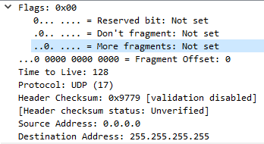

**QUESTION:8**

What IP address is the DHCP server offering to your host in the DHCP Offer message? Indicate which DHCP message contains the offered DHCP address.

**IP address DHCP Offer message:**

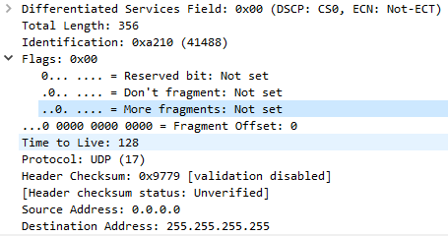

**DHCP message contains the offered DHCP address:**

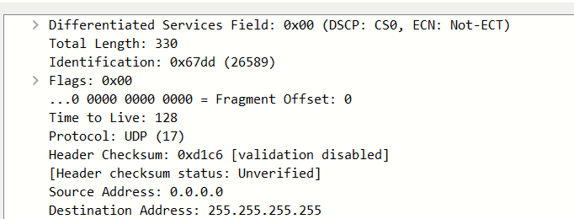

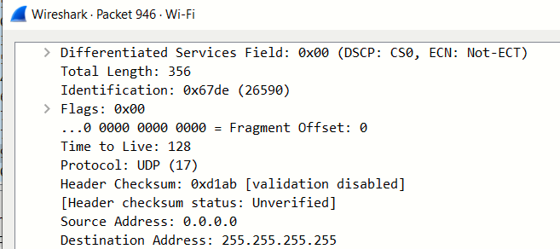

**QUESTION:9**

Explain the purpose of the router and subnet mask lines in the DHCP offer

message.

The IP address for the router identifies the default internet gateway. The subnet mask defines the subnet mask that is available.

**QUESTION:10**

Explain the purpose of the lease time. How long is the lease time in your experiment?

When server assign us a lease time until we release it can’t assign it to any other. The lease time is the amount of the time the user is aloud connection to the router.  
**QUESTION:11**

What is the purpose of the DHCP release message? Does the DHCP server issue

an acknowledgment of receipt of the client’s DHCP request? What would happen if the client’s DHCP release message is lost?

* Release message tells us about the IP address when disconnected from our device.
* No DHCP issue an acknowledgment of receipt of the client’s DHCP request.
* If release message is lost then it can’t assigned us a network.